Name : ibraheem Qasim

Sap id : 42896

Section : BSCS 5

**Lab task 5**

**Code screenshot :**

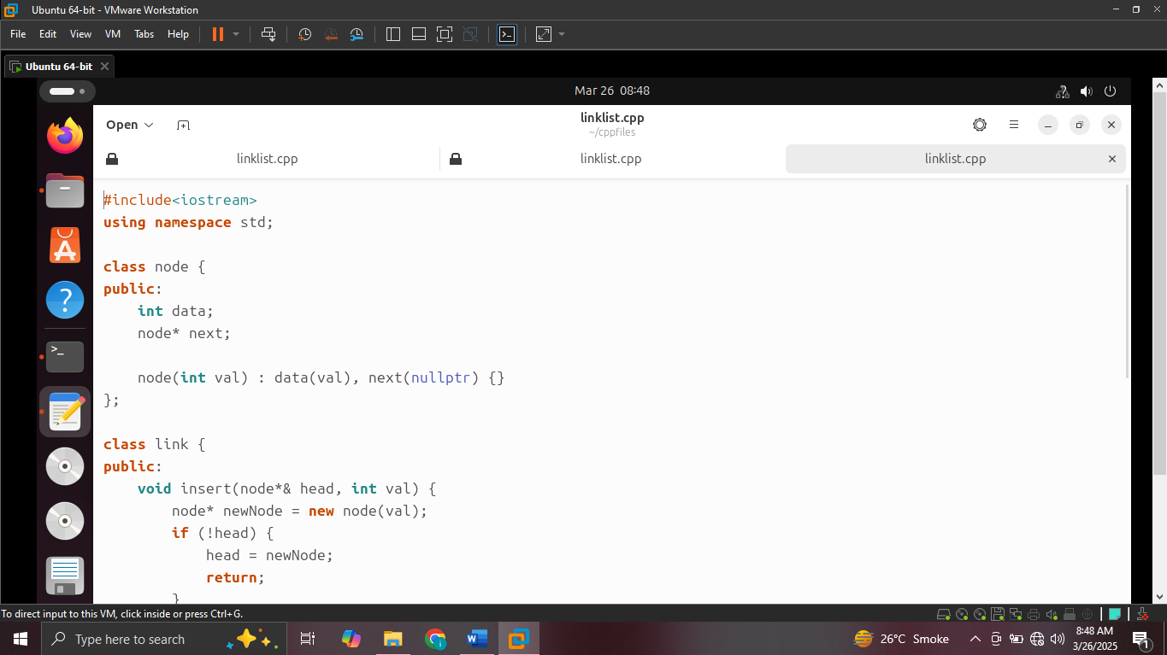

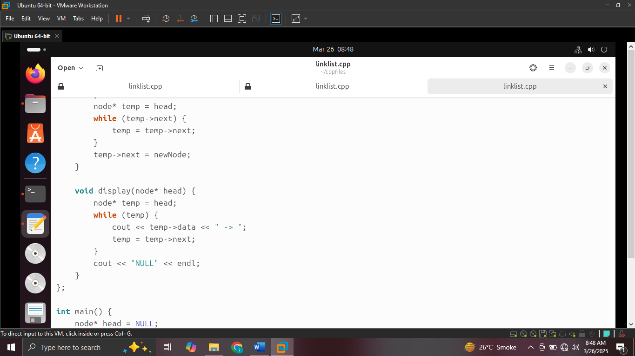

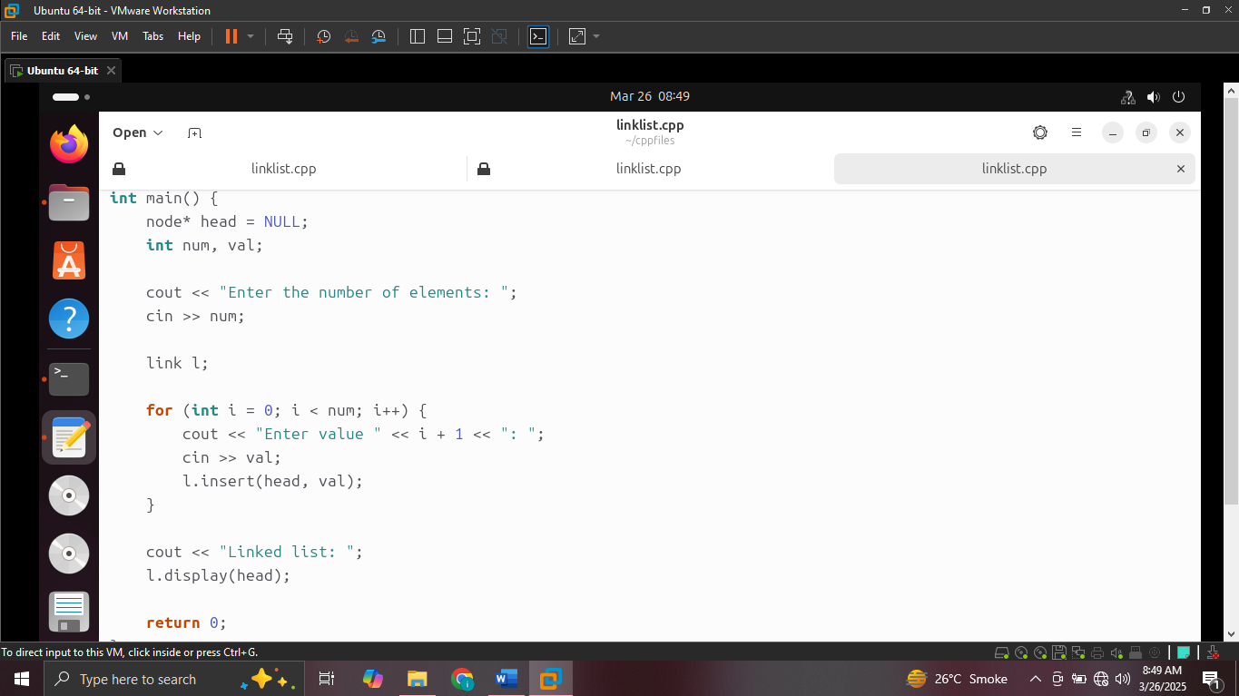

**Output screenshot :**

